**Bip**

**毕普先生**

（英文部分选自经济学人20070927讣告）

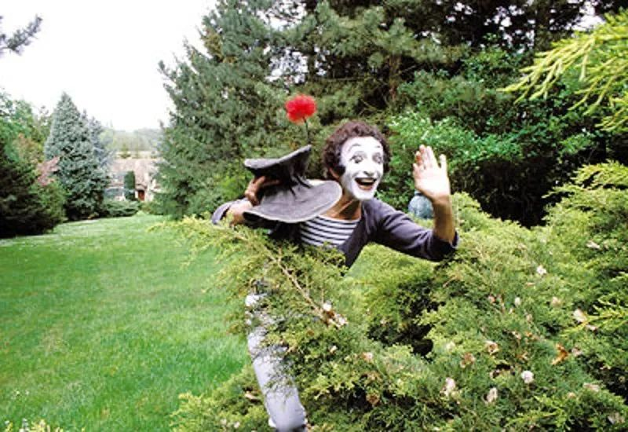

Bip  
毕普先生

**Bip, the world’s quietest clown, died on September 22nd, older than he seemed世界上最安静的小丑毕普先生于2007年9月22日去世，年纪比他看起来更大**。

When the spotlight **faded on** Bip last week, leaving not even a hand or a flower illuminated, it caused only a sigh of surprise. Bip had tried many times to **put an end to** himself. He would cut his wrists with a blade, nicking and wincing away from it, in case his copious blood gushed over his pure white sailor’s trousers. He would **shake out into** his palm a handful of pills from a bottle, open his wide red mouth, and fail to swallow them. **Stepping on** a chair that wobbled under him, he would knot a noose round his scrawny neck, test it, yank it, gyrate his neck like a pigeon and step out into the void. **Nothing worked**. He went on living.

上周，聚光灯在毕普先生身上淡去，连一只手或一朵花都不再被照亮时，只引起一声惊叹。毕普曾多次尝试了结自己，他试过用刀片割腕，割开一个小口子，然后又退缩了，担心自己的汩汩鲜血会喷溅到纯白的水手裤上。他也试过摇晃瓶子，往手里倒上一把药，张开红色的大嘴巴，最后却没能吞下去。他还试过站在摇摇晃晃的椅子上，往自己骨瘦如柴的脖子上套上绞索，测试一下，然后猛地一拉，绞索拉着他的脖子像鸽子一样转起来，双脚也蹬掉了椅子。**这些都没用**。他还是活着。

That he should wish to die was also not surprising. Often he was kept, crouching or standing, in a small cage on the stage. One by one he ran his hands along the bars until, with all his strength, he pushed two apart and jumped nimbly out; but then, right ahead of him, behind him, all round him, he found his palms flattening against a wall of glass. Each cage was contained in another. His hands often became birds, flickering and fluttering out of his sleeves, and he made them fly swiftly from their prisons, laughing as they flew. But the bars soon closed again round him. 

他想死，也并不意外。他经常被关在舞台上的一个小笼子里，时而蹲着，时而站着。他双手顺着一根根围栏摸索，用尽力气拉开两根栏杆，敏捷地跳出来；但是接着，他伸出手去，却发现自己前后左右碰到的都是玻璃墙。笼子一个套着一个。他的双手经常化作小鸟，忽闪忽闪从衣袖里扑腾出来，飞快地逃离牢笼，而他也会笑着看它们飞走。但是，他很快又被围栏困住了。

Like all human beings, he dreamed; but his dreams were rarely successful. He hunted butterflies with a darting net, only to break their wings. He plucked flowers, then picked their petals out, and was surprised they died. When he tried to tame lions, they ate him, scorning the thin hoop he flourished in their direction. He walked against wind and **made no progress**. His **black-ringed** **eyes** and **black-lined eyebrows** registered sadness, wonder, perplexity and terror. But he did not know what malevolence was. He was, said the man who knew him best, a romantic, a Don Quixote tilting at windmills, and “alone in a fragile world filled with injustice and beauty”. 

和所有人一样，毕普也有过梦想，但是他的梦想很少成真。他拿网捕蝴蝶，却把它们的翅膀折碎了。他采摘花朵，把花瓣一片片摘掉，诧异地看着花儿们死去。他尝试驯服狮子，狮子却想把他吃掉，对他手里挥动的细铁环不屑一顾。他逆风前行，**却还是原地打转**。他长出了**黑眼圈**，**眉毛**也描得漆黑，都流露出悲伤、好奇、困惑与恐惧。但是他不知道什么是恶毒。最了解他的人这么说：他是一个浪漫的、和风车搏斗的堂吉诃德，“在一个充满不公和美好的脆弱世界里孤独前行”。

To the naked eye Bip had only the clothes he stood up in: trousers, jacket, soft ballet shoes, striped jersey, and a crumpled opera-hattopped with a red flower. His lean limbs and white face were his only language. The spotlight played on him, and nothing else. Yet the silence around him was filled with chairs, tables, animals, trunks and escalators. It swarmed with lounging waiters, officious policemen, dog-walkers pulled to right and left of the path, old ladies knitting. Railway trains roared through, and Bip, bouncing and swaying in his seat, struggled to keep his suitcase from falling out of the rack. The sea flooded in, bringing a ship that could take Bip on his constant travels to America, to Japan and to Australia, and he staggered manfully up and down the pitching deck.

肉眼看去，毕普只有表演时穿的那一身衣服：长裤、夹克、软芭蕾舞鞋、条纹运动衫和一顶皱皱巴巴插着红花的歌剧帽。瘦弱的四肢和苍白的面容是他唯一的语言；聚光灯打在他身上，仅此而已。然而，他四周的寂静却被椅子、桌子、动物、行李箱和自动扶梯填得满满当当，挤满了懒洋洋的服务生、爱管闲事的警察、被狗拽着左右移动的遛狗人和织毛衣的老太太。火车呼啸而过，毕普在座位上颠来颠去，摇摇晃晃，努力不让他的行李箱从行李架上掉落。海水汹涌而来，把一艘船冲到了他身前，而这艘船可以载着毕普一路去往美国、日本和澳大利亚；然后，他便勇敢地走在颠簸的甲板上。

He was born, some said, in the Paris acting school in 1947, bred by Jean-Louis Barrault in “Les Enfants du Paradis” and raised at the tiny Théâtre de Poche in Montparnasse. Others made him far older, dating from the Athenian drama and the Japanese noh plays, via the commedia dell'arte and Charlie Chaplin. Parts of all this went into the making of him, as well as the imaginings of the young Marcel Marceau, in Strasbourg in the 1930s, trying on his father's long trousers and contorting his body to make his friends laugh. His name, Bip, came loosely from Dickens's “Great Expectations”. His hat, flower and sailor-costume solidified over time.

有人说，毕普这个角色生于1947年的巴黎表演学校，是让–路易·巴劳（Jean-Louis Barrault）在《天堂的孩子们》当中创造出来、又在蒙帕纳斯的袖珍剧院中成长的。其他人则认为他的历史要更久远，可以追溯到雅典戏剧和日本能剧，经由意大利即兴喜剧和查理·卓别林发展而来。所有这些都参与创造了毕普，年轻的马歇·马叟（Marcel Marceau）脑海中的想象也成了毕普的一部分。早在20世纪30年代的斯特拉斯堡，马叟就穿着父亲的长裤，扭动自己的身体，逗得朋友们哈哈大笑。他之所以取名叫“毕普”，大概是受到了狄更斯《远大前程》的启发。随着时间的推移，他的帽子、鲜花和水手装扮也逐渐深入人心。

Becoming the tempest

成为风暴

He never spoke. Mr Marceau's father died in 1944 in Auschwitz, and Bip's silence was a **tribute to** all those who had been silenced in the camps. It was a recollection, too, of the necessary muteness of resistance fighters caught by the Nazis, or quietly leading children across the Swiss border to safety, as Mr Marceau had done. In one of his acts, “Bip Remembers”, the sad-faced clown relived in mime the horrors of the war and stressed the necessity of love. In another, his hands became good and evil: evil clenched and jerky, good flowing and emollient, with good just winning.

他从不说话。1944年，马叟的父亲死于奥斯维辛（Auschwitz）集中营，毕普的沉默是向所有被集中营剥夺了声音的人致敬。他的沉默也是一种追忆，追忆那些被纳粹俘虏的抵抗组织战士必要的沉默，追忆像他一样悄悄带领孩子们越过瑞士边境到达安全地带的人。作品《毕普会铭记》中，这个愁眉苦脸的小丑以哑剧的形式重现了战争的恐怖，强调了爱的必要性。在另一部作品中，他的双手变成善与恶的化身：恶之手紧握而抖动，善之手流畅而缓和，善战胜了恶。

His alter ego, who promoted him as Everyman all over the world, sometimes spoke for him. “Bip”, said Mr Marceau, “is a hero of our time. His gaze is turned not only towards heaven, but into the hearts of men.” Mr Marceau compiled his biography and painted his portrait, colouring him blue, rose and mauve as he walked through the city streets and sailed among the stars. He wrote a poem for him:

他的另一重人格有时会借他的嘴说话，也促成了这个世界知名的凡人角色。马叟先生说：“毕普是我们时代的英雄。他的目光不仅投向天堂，也投向人们的内心。” 马叟先生整理了毕普的生平，为他绘制肖像——蓝色、玫瑰色和淡紫色是毕普的形象，他穿过城市街道，在星空中航行。他为毕普写了一首诗：

注：The everyman is a stock character in fiction. An ordinary and humble character, the everyman is generally a protagonist whose benign conduct fosters the audience's wide identification with him. 见维基百科：https://en.wikipedia.org/wiki/Everyman 

A silent, fragile hand has drawn in space a white flower emptied of its blood. Soon it will open, blossom out. Soon, though faded, bloom again.

一只沉默脆弱的手在空中画出一朵耗尽血色的白花。很快它将盛开。很快，即便褪色，也会再次绽放。

Mr Marceau was garrulous and gregarious where Bip was not. He ran his own mime company for almost 60 years, staging mimodrames when they were completely out of fashion, and started an international school in Paris to teach his skills to others. No mime artist could touch him. Hollywood loved him. Mr Marceau gave interviews frequently, sometimes in Bip's clothes, explaining him to the crowd: “If I do this, I feel that I am a bird. If I do this, I am a fish. And I feel that, if I do this, it's like a song...To mime the wind, one becomes a tempest. Mime expresses...the soul's most secret aspiration.”

与毕普相反，马叟先生非常健谈，热爱交际。他经营自己的哑剧公司将近60年之久，即使哑剧不再流行的时候也仍然坚守阵地，还在巴黎开设了一家国际学校，专门传授自己的表演技巧。没有哪位哑剧演员能与他比肩。好莱坞也欣赏他。马叟先生经常接受采访，有时穿着毕普的衣服，向观众阐释这个人物：“如果我这样做，我感觉我是一只鸟。如果这样做，我就是一只鱼。如果是像这样，感觉像一首歌…要模仿风的话，自己就得变成风暴。哑剧能够表达灵魂最神秘的渴望。”

Bip simply moved on the stage, bird, fish, song, wind, tempestuously without a word, until he too became invisible.

毕普只是在舞台摆动身体，他像鸟，像鱼，像歌又像风，像风暴一般汹涌，却又一言不发；最后，就连他自己也化为无形。